# TIA Portal Integration Guide for In-Sight & Dataman

Author: Matthew Taylor

Published: 4/30/2018

Revision: Draft 0.1

## Overview

The purpose of this document is to outline the steps needed to add a PLC and a Dataman or In-Sight (4.x or 5.x firmware) sensor to a TIA Portal project, and to use the ProfiNet Tag Generator spreadsheet to generate tags for either sensor.

**Integration steps**

# To create a project with the TIA Portal software, first launch the software and from the Project drop down, create a new project

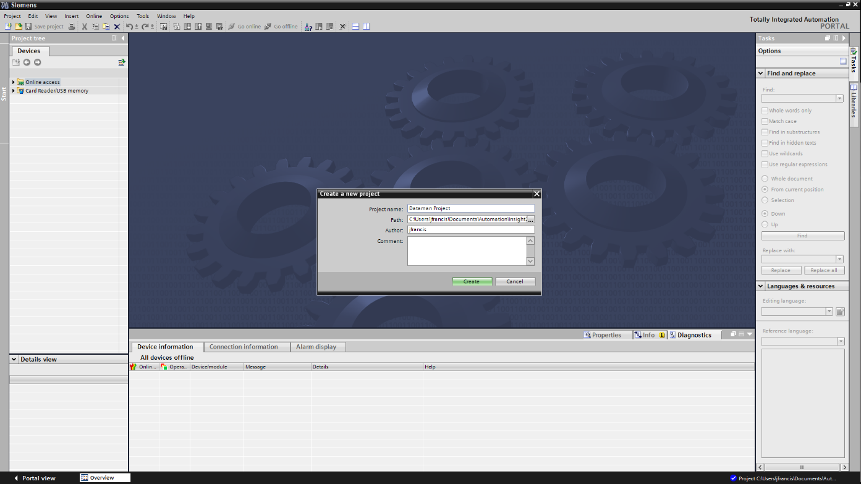

Under the Project Tree on the left side of the application, double click on Add new Device, and select your controller from the list.

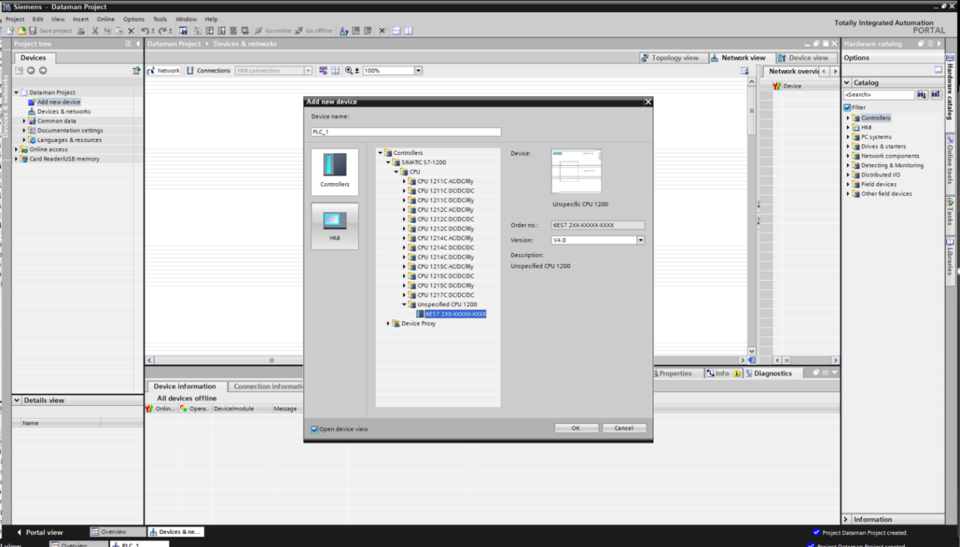

Next you need to install the GSD file for the product you are connecting. Select Options -> Manage General Station Description Files (GSD). Once this file has been installed, you will be able to select any supported Cognex product from the catalog on the right side of the application. Best practice is to use the GSD file from the version of software that matches the version of firmware running on your camera.

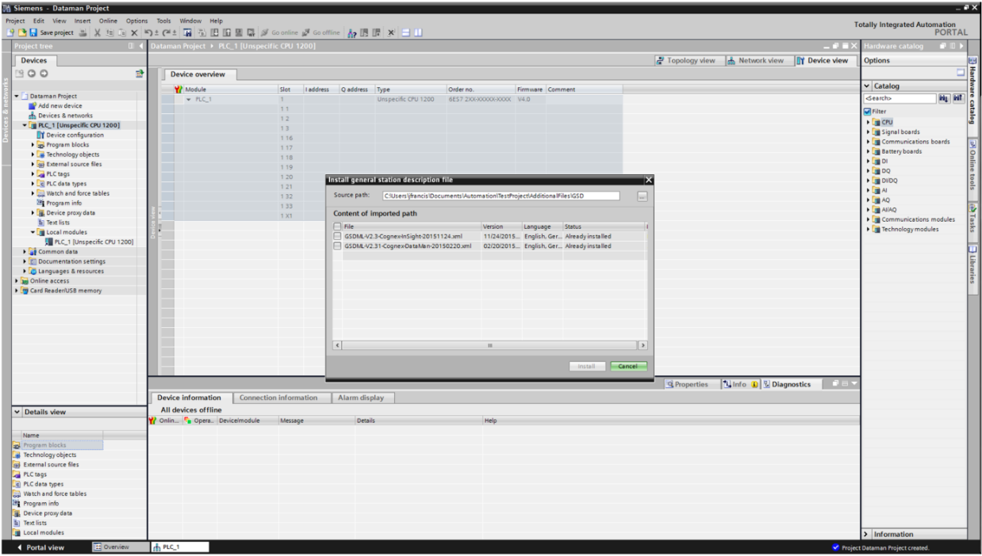

Finish setting up the PLC based on the specific model you have. This may mean double clicking on the network port on the controller in the Devices and Networks window and assigning an IP address, as well as naming the controller. Work your way down through all the settings in the list view under the Devices and Networks window:

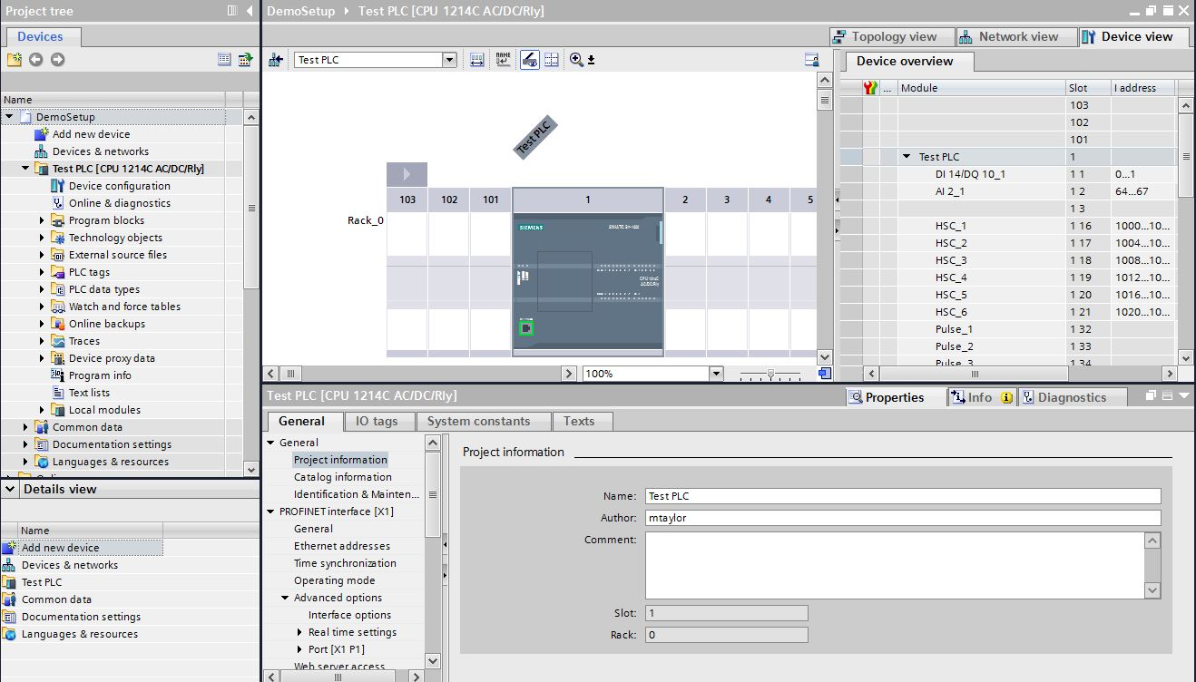

Once the PLC has been added and configured you can now add your Cognex camera. Double click again on the Devices and Networks option from the Project Tree on the left. Then expand the catalog on the right for Other Field Devices (you may have to turn off filtering to see this option). Then expand PROFINET IO > Sensors > Cognex Corp > (Cognex ID Readers/Cognex Vision Sensors) and select your device from the list, and drag it into the window with the PLC controller.

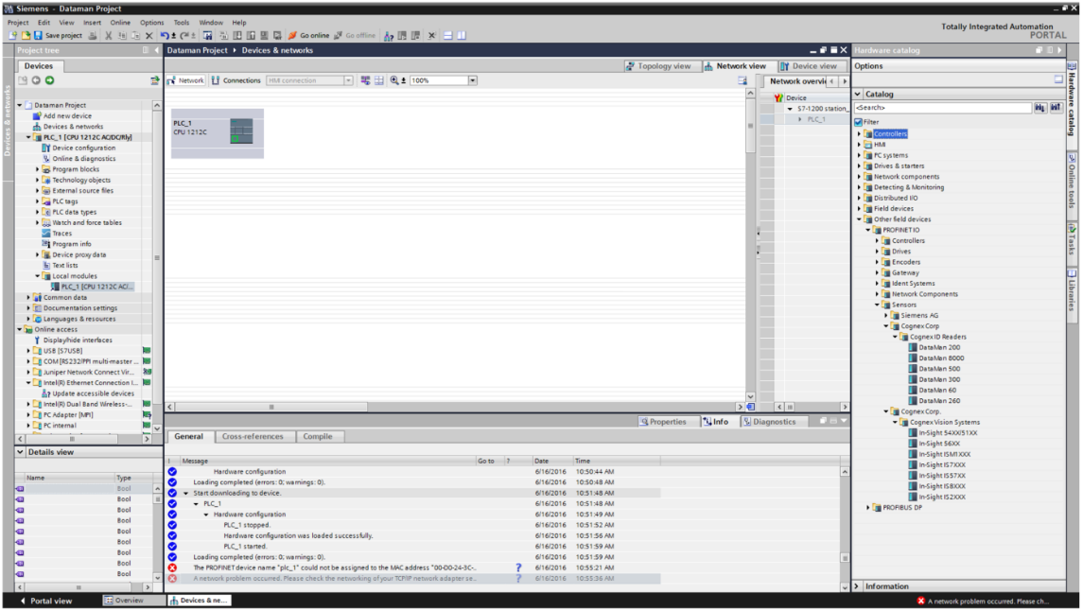

The camera will show up as Not Assigned. If you click the link you can select the PLC you added in the previous step and you will get a link between the two. Just like for the PLC, double clicking on the camera name above the module will allow you to enter in names and IP addresses of the device. Note, it is not recommended to let the PLC assign the IP address to the camera, so be sure to check ‘IP Address is set directly at the device.’ Also when naming the device, be sure to match what the reader is named and make is all lower case alpha numeric. When you are done, you should have something looking like this:

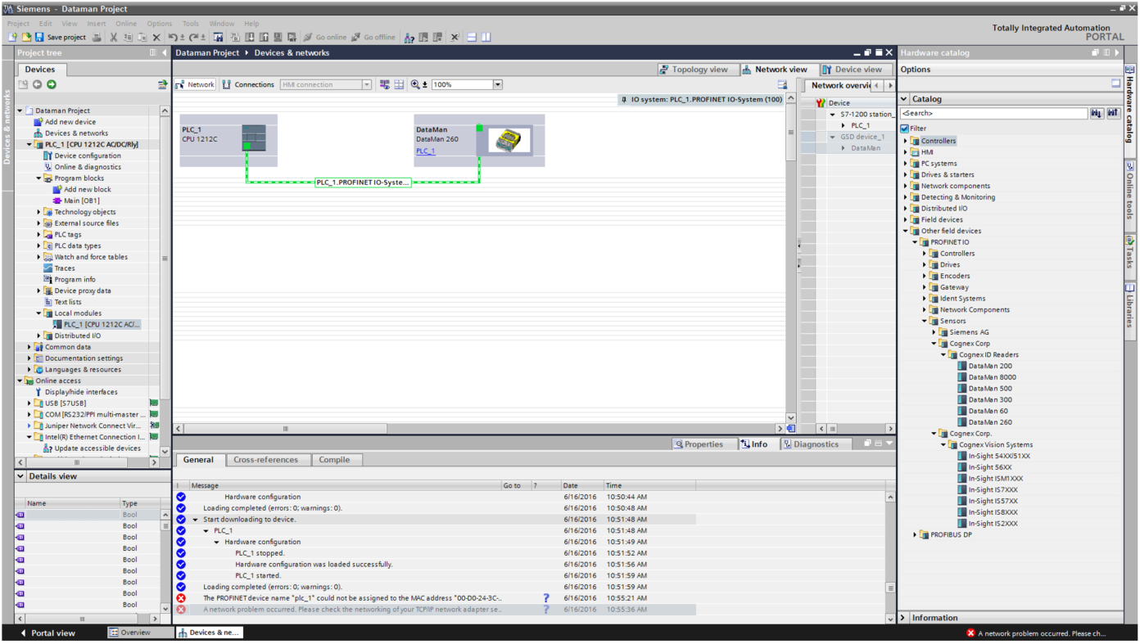

Now that the hardware configuration is complete, we can now use the inculded spreadsheet to generate all of the control and status tags. From the project tree expand the CPU node and double click Device Configuration. From the Devices & Networks window, select the Network View tab as shown below:

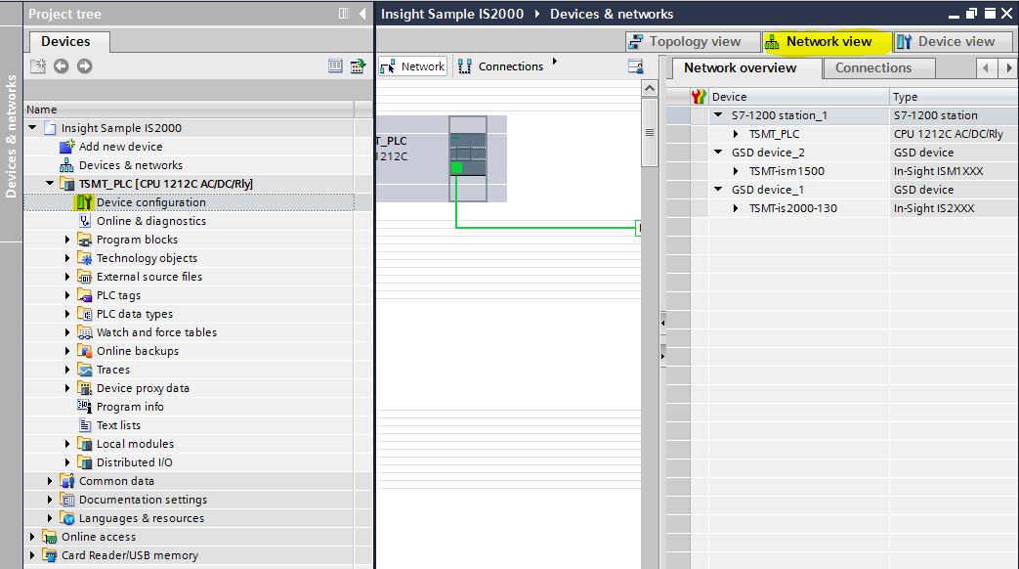

Double click on the device we just added in the Devices and Networks window. This will show the device overview to the right of the camera. You can expand and resize the window to see the start address for each of the control and status modules for your device

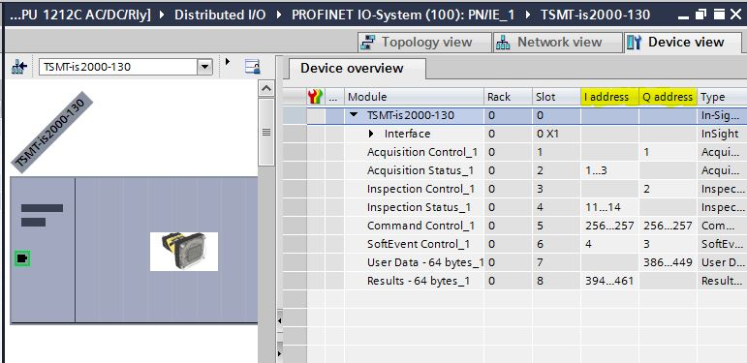

These control and status modules match what is in the spreadsheet. Note the spreadsheet has a tab for Insight cameras running 4.x firmware, 5.x firmware, and one for all Dataman scanners. This is where you will find the start address for each module. These are the start addresses that need to be entered into the ProfiNet Tag Generator spreadsheet.

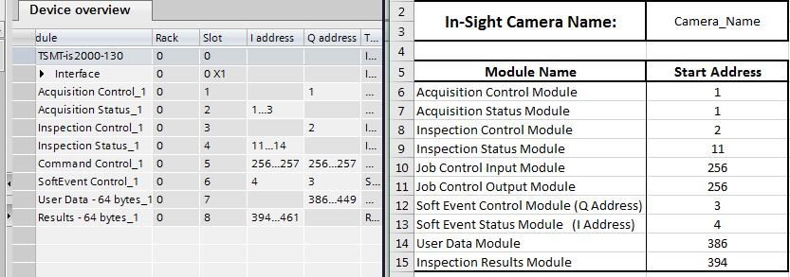

There are instructions in the spreadsheet in cell $A$17 for what cells to select from the spreadsheet once the start addresses have been entered. In the TIA Portal software, expand the PLC Tags and double click on the Add new tag table option

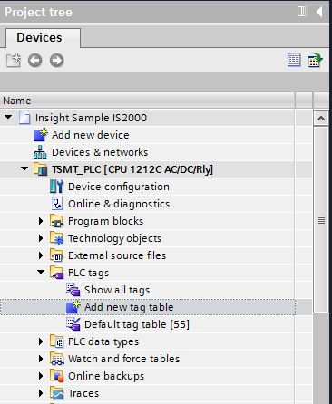

Once inside the newly created tag table you can right click on the first open tag name space and select Paste to paste the contents from the excel spreadsheet. 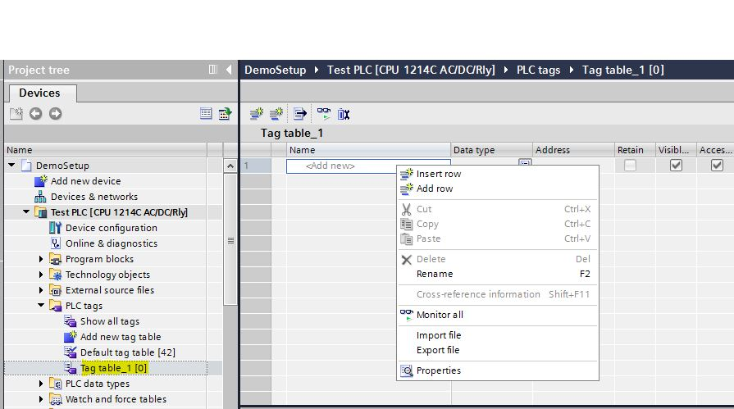

You will see that the tag names, data types, and addresses are now populated, and all tags have been generated. These tags can now be used through the PLC logic:

